E-Commerce Application - SOEN 341 Section SA

Minutes Meeting - Sprint 4.1 04/01/2022

horizontal line

**01 April 2022 / 8:00 PM / DISCORD**

# ATTENDEES

William Tremblay, Harrison Zhang, Alan Matthew Vadlakunta, Alice Chen

# AGENDA

## **Last Meeting Follow-up**

## **Decisions**

* [Create a mockup layout for the shopping cart](https://github.com/Its-Alann/groupD-soen341project2022/issues/169) - To be completed by this Saturday, April 2nd
* [Implement the mockup layout for the shopping cart](https://github.com/Its-Alann/groupD-soen341project2022/issues/170) - To be completed by Sunday, April 3rd
* [Create a way to store items in shopping cart for users](https://github.com/Its-Alann/groupD-soen341project2022/issues/171) + Add to Cart Button (using LocalStorage) - To be completed by Tuesday, April 5th
* [Save shopping cart info for when user logs out](https://github.com/Its-Alann/groupD-soen341project2022/issues/172) - To be completed by Sunday, April 10th
* [Add, remove and reduce buttons for each item in the shopping cart](https://github.com/Its-Alann/groupD-soen341project2022/issues/173) - To be completed by Sunday, April 10th

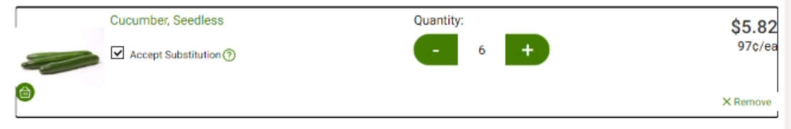

* [Display total price of shopping cart at checkout](https://github.com/Its-Alann/groupD-soen341project2022/issues/174) - To be completed by Monday, April 11th
* [Button that brings user to the payment page](https://github.com/Its-Alann/groupD-soen341project2022/issues/175) + Payment page - To be completed by Tuesday, April 5th
* Record video
  + For demo sections, record their screen to show demo
  + Individual part - To be completed by April 11th
  + Alan - editing all videos together by April 12th
* Assign Section from Presentation:
  + Presentation slide: 43 sec/person
  + Project purpose: Harrison (one spot left)
  + Overall architecture: Will (one spot left)
  + Stories: Alice
  + Lesson learned: (one spot left)
  + Summary: Alan
* Write text in google doc and to be reviewed by everyone
* Testing Framework: to be implemented with the React Framework
* Automation Testing: completed already, done with Github

NOTES

* Admin: Be able edit the user logins (add user/remove user) - Alan, Date to be completed: TBD

# ACTION ITEMS

1. Assigned tasks from Sprint should be completed according to their dates, as indicated in the Decision section
2. Emily, Georgia and Leon to decide their section for the presentation

# NEXT WEEK’S AGENDA

Next meeting: **TBD**